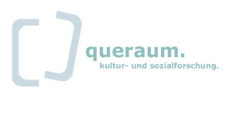
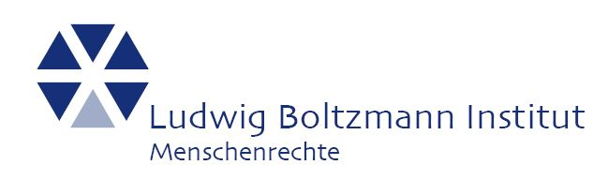
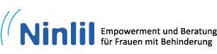

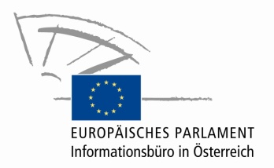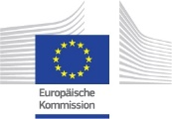

Access To Specialised Victim Support Services
For Women with Disabilities Who Have Experienced Violence

European Conference

Vienna, 28 January 2015
House of the European Union
Wipplingerstraße 35, 1010 Vienna

Organized by the Ludwig Boltzmann Institute of Human Rights (BIM)

Date: Wednesday, 28 January 2015
Time: 09:00 – 18:00
Place: Vienna, Austria
Venue: House of the European Union,
Wipplingerstraße 35, 1010 Vienna
Language: Austrian Sign Language (ÖGS)/ German/ English (simultaneous interpretation provided)

Background Information

The European Union as well as the participating countries have taken many measures to fight against discrimination and violence and promoting women’s rights. Furthermore many policies and programmes have been established to focus on the advancement of the rights and improve the situation of persons with disabilities. Unfortunately, there has been a gap in coordination, cooperation and mainstreaming in the specific case of women with disabilities in these policies: the gender angle is often forgotten in disability policies and disability is overlooked in gender equality policies as the European Disability Forum found out in 2009. Nearly 80% of women with disabilities have been victims of psychological and physical violence and stand a greater risk of sexual abuse than women without disabilities; violence is not only a common feature of the lives of women with disabilities but can also be the actual cause of disability, was declared by the European Parliament in 2006. A broad German survey reported that women with disabilities were twice or three times as likely to suffer sexual violence and twice as likely to suffer physical violence as women in the average population (Schröttle, 2012).
Taken this into account the project “Access to specialized victim support services for women who have experienced violence” was developed and funded by the Daphne III Programme of the European Commission.
The Ludwig Boltzmann Institute of Human Rights (leading organisation) carried out the project (2013-2015) together with Ninlil and Queraum in Austria and the universitites from Gießen in Germany, Leeds and Glasglow in Great Britain and Iceland. The project was characterized by a women`s rights and disability rights approach and aimed to find out if women with disabilities, who have experienced violence, have access to specialized victim support sercvices, such as shelters, women’s helplines, Intervention centers for women survivor’s of domestic violence, women counselling centers, etc. on an equal basis with women without disabilities.
To examine this, it was of high importance to come to know the views of women with disabilities, learning about their life stories and experiences of violence also in relation to existing barriers and obstacles. On the other hand co-workers as well as heads of victim support services where asked to express their concerns and wishes in the context of accessible support for women with disabilities.
Another specific goal was the development and strengthening of cooperation and communication among specialised victim support services and Disabled People’s Organisations.
Above all women with disabilities should benefit from the results of the project, which will be presented at this european conference.

The following questions will be explored during the conference:

- What is included, within the international and European human rights framework, in relation to violence against women with disabilities?

- To what extent do the existing national laws and policies, in different European countries, include the prevention and protection of women with disabilities from violence and their access to support services? Are there good practices? Where can we learn from each other?

- How can we promote the rights of women with disabilities and improve their accessibility to support services in the future? Who should be addressed in the realisation of the full rights for women with disabilities?

AGENDA

Moderator: Ms Dorothea Brozek

Morning
08.30 – 09.00  09:00 – 10:00  10:00 – 11:15 | Registration  Official welcome by Brigitte Luggin, House of the European Union, Gabriele Heinisch-Hosek Federal Minister for Women and Education, Hana Velecka, Delegate of the European Commission, Directorate Rights of Persons with Disabilities, Sabine Mandl, BIM & Project Lead  Panel 1: Project Presentation  - Presentation of the project and the main results (Sabine Mandl)  - Presentation of Country Results: Monika Schröttle (University Gießen, Germany), Sarah Woodin und Sonali Shah (Universities Leeds and Glasgow, United Kingdom), Rannveig Traustadottir and Hrafnhildur Snæfridar- og Gunnarsdottir (University Iceland, Iceland), Claudia Sprenger (BIM, Austria)

11:15 – 11:45 Coffee Break

Continuation Morning
11:45-12:45 | Key Note Speech: “Violence against Women with Disabilities” – International and European Human Rights perspective, Ana Peláez Narváez (Member of the Committee on the Rights of Persons with Disabilities, Director of International Relations at the Spanish National Organisation of the Blind (ONCE)  Q&A and Discussion

12.45 – 14:15 Lunch break (Buffet Lunch offered at the venue)

Afternoon
14.15 – 15:30 | Panel 1: Access to Specialized Victim Support Services for Women with Disabilities Who Have Experienced Violence: Status Quo, Good-practices and challenges: Susie Balderston (Vision Sense, United Kingdom), Brigitte Faber (Weibernetz e.V., Germany), Gabi Plattner (Tirolean Women’s Shelters, Austria), Helga Baldvins- og Bjargardóttir (Support Counselling Centre For Survivors of Violence, Iceland)  Q&A and Discussion

15:30 – 16:00 Coffee Break

Continuation Afternoon
16:00-17:15  17:15 – 18.00 | Panel 2: Access to Specialized Victim Support Services for Women with Disabilities Who Have Experience Violence: Suggestions for improvement and future perspectives Elisabeth Löffler (Ninlil, Austria), Teresa Lugstein (make it, office for promotion of girls of the Province of Salzburg, Austria), Mridul Wadhwa (Shakti Women's Aid, United Kingdom), Þorbera Fjölnisdóttir (Öryrkjabandalag Íslands/Organisation of Disabled in Iceland,Iceland)  Q&A and Discussion  Wrap up of the Day (Moderator)  Farewell (Project Team)

