‘ Access to Specialised Victim Support Services for Disabled and Deaf Women who Experience Violence’

‘ Access to Specialised Victim Support Service for Disabled Women who Experience Violence’  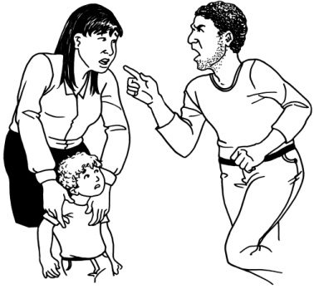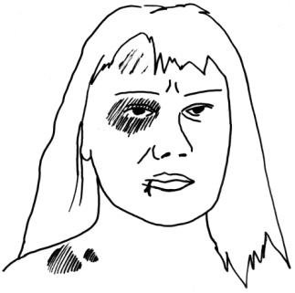  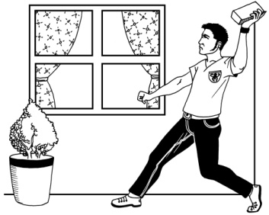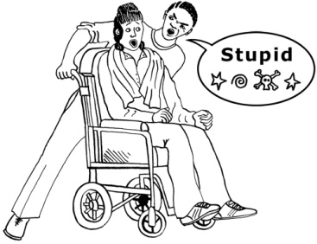  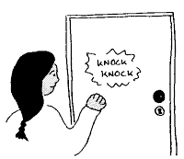  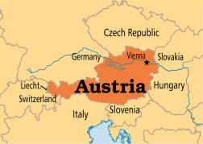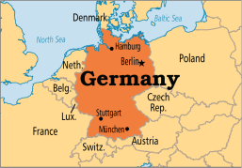  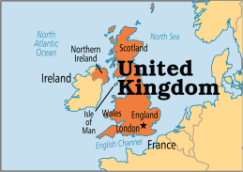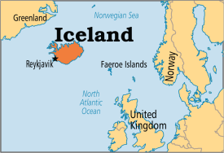  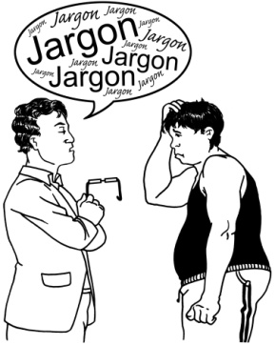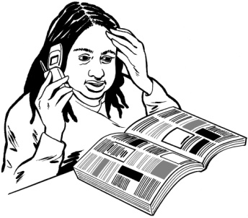  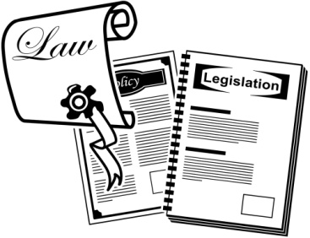  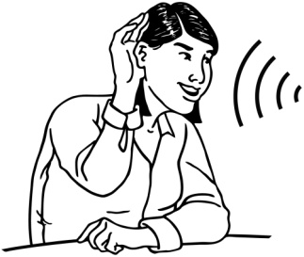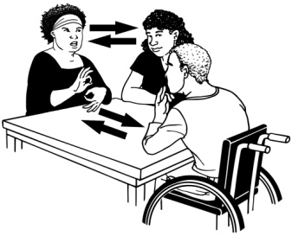  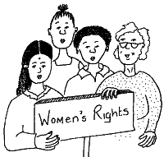  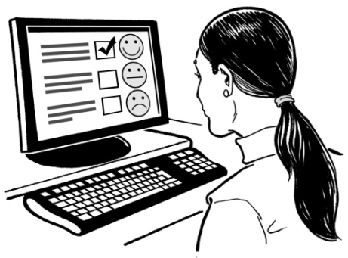  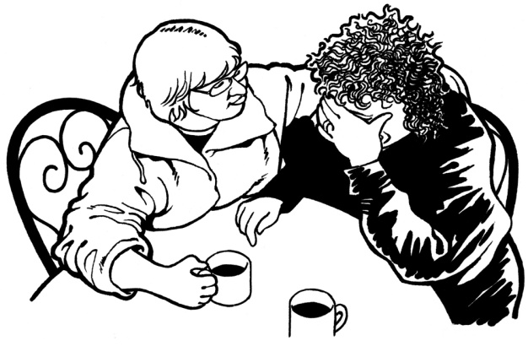  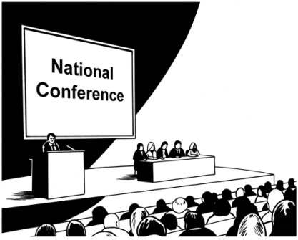  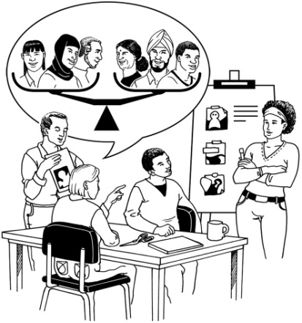  Please can you add logo and contact details? | We are doing research to find out how to help disabled and Deaf women who have experienced violence from other people.  Violence means being treated badly, being bullied, being hit and being hurt. It can be having things stolen or damaged and people pretending to be your friend but often being nasty to you.  We are finding out if disabled women who have been hurt by other people get help from services.  Four places are finding out what is happening in their countries:  Austria, Germany, UK and Iceland.  WHY ARE WE DOING THIS?  Disabled and Deaf women often get treated worse, are bullied more and get hurt more than non-disabled women and more than men.  Often disabled and Deaf women do not get enough help from services that help women.  There are laws that say disabled women should not be hurt. But sometimes the laws do enough to stop the violence. They do not always work properly.  HOW WE ARE DOING THE RESEARCH  We are doing interviews and having discussion groups to find out what disabled and Deaf women think. We want to know about:  - What help disabled and Deaf women need  - If disabled women know about their rights  - If women get the help they expect  We are doing a computer survey with questions for support services..  We are asking women’s services and disabled people’s organisations how they are helping disabled and Deaf women who have been hurt. We are asking:  - If services can do enough to help disabled and Deaf women  - About which services are good. .  WHAT WILL WE DO WITH THE RESEARCH?  Stories will help to tell everyone about the problems. They will also help us learn how to keep women safe.  We will help disabled people’s organisations and women’s organisations to talk to each other, to solve problems.  We will tell the governments in our countries about the problems for disabled and Deaf women.  We will make easy read brochures.  WHO ARE WE?  Ludwig Boltzmann Institut für Menschenrechte (link)  Sabine Mandl  Claudia Sprenger  Julia Planitzer  Austrian partners:  Ninlil: Association against sexual violence of women with learning difficulties and multiple disabilities (link)  Elisabeth Udl  Queraum: Cultural and social research organization (link)  Anna Schachner  Oliver König  European partners:  University Giessen: (link)  Monika Schröttle  Kathrin Vogt  U.K. Partners  Sonali Shah – University of Glasgow: http://www.gla.ac.uk/schools/socialpolitical/research/sociology/strathclydecentrefordisabilityresearch/  Sonali.Shah@glasgow.ac.uk  Sarah Wooden - University of Leeds: http://disability-studies.leeds.ac.uk/  s.l.woodin@leeds.ac.uk  University Island: (link)  Rannveig Traustadóttir  Hrafnhildur Snæfríðar- og Gunnarsdóttir

